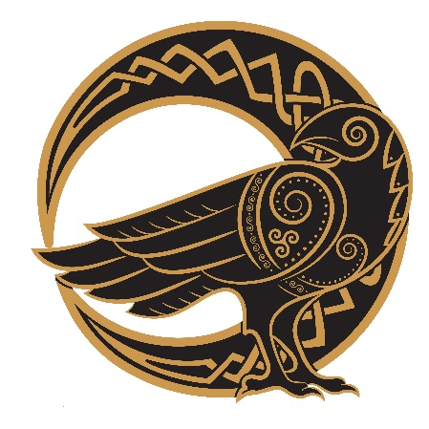
BLACKBIRD FEIS
Registered with IDC Dublin 3256/21
DATE: 19TH September 2021
VENUE: Wollongong High school, Lysaght street, Fairy Meadows.
ADJUDICATOR: Allison Bennett ADCRG
ENTRIES CLOSE: 5th September 2021
FEES : $40.00 Beginner & Primary & Elementary.
$45.00 Intermediate & Open
$10.00 Door Fee
Direct Debit A/C 053 150 344 BSB 112 879 JBird
Families of 3 or more receive 15% discount

Email entries to jennib44@bigpond.com

Please circle dance | Total
Beginner Premiership Jig Reel or extra Jig
Primary Premiership Jig 96 88 82 Reel
Elementary Premiership Jig Hornpipe Reel Slip Jig Set
Open Premiership Jig Hornpipe Reel Slip Jig Set

NAME

AGE 1/01/20

SET DANCE NAME
SET DANCE SPEED

STUDIO

EMAIL ADDRESS

CONTACT NUMBER

Total fees included
$10 Door Fee
The organisers will provide a safe environment for all. Dancers enter at their own risk.

